Computer Networks Lab 01
Name: Hafsa Salman
Roll no. 22K-5161

Question no. 01
Command: ipconfig
IP Address: 192.168.0.1
Screenshot:
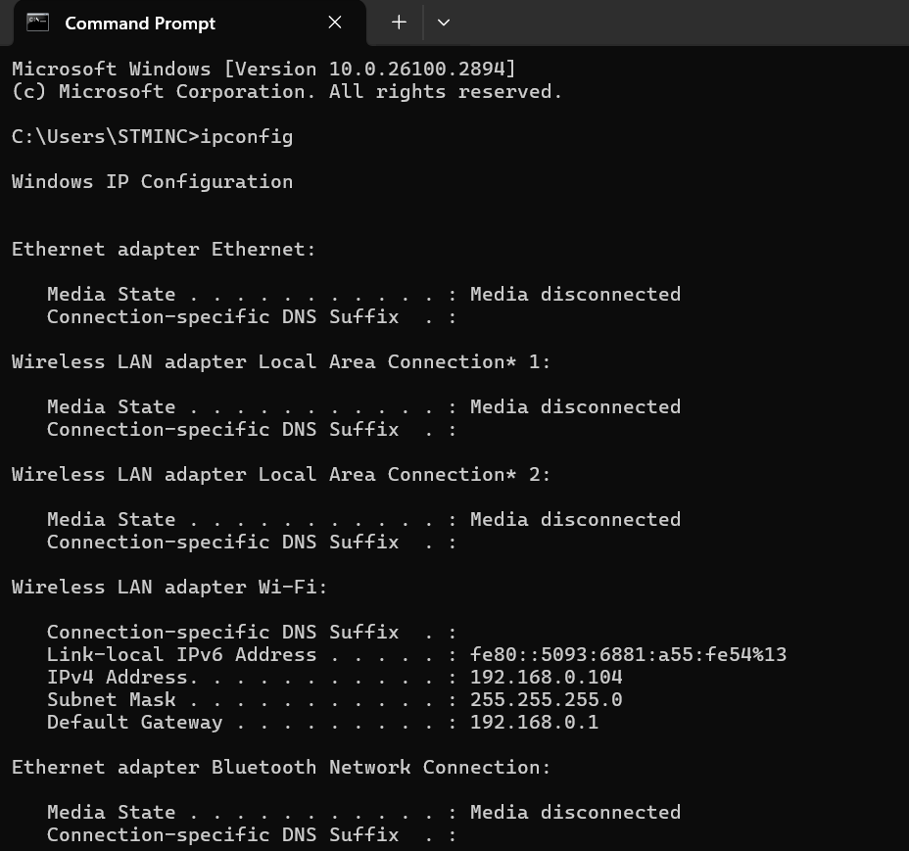

Question no. 02
Command: ipconfig/all
IP Address: 192.168.0.1
MAC Address: 84-A9-38-D0-ED-15
DHCP: Enabled
Screenshot:
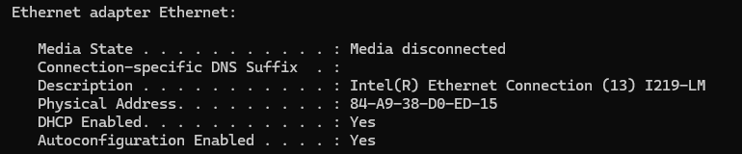

Question no. 03
Command: hostname
IP Address: 192.168.0.1
Hostname: Wheeeeee
Screenshot:


Question no. 04
Command: computer 1: ping ip address compuer 2: ping hostname
Reason: Computers are not connected properly to the network.

Question no. 05
Command: netstat -a
Screenshot:
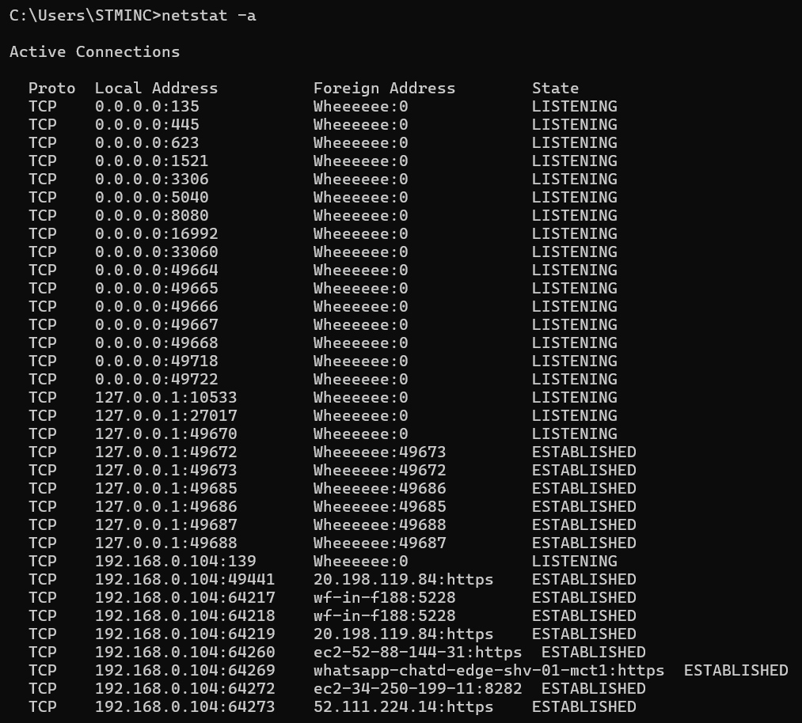

Question no. 06
Command: tracert www.google.com
Screenshot:
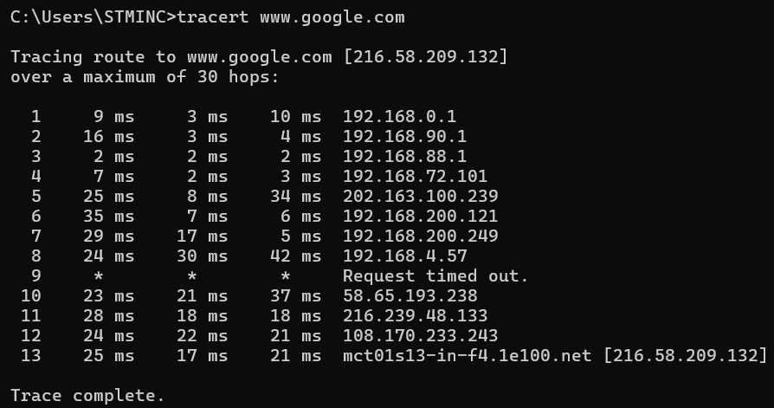

Question no. 07
Reason: Blue machine is not a network.

Question no. 08
Answer: Optical Fiber; they have larger bandwidth and are faster.

Question no. 09
Answer: Straight-through cable can be used to connect router or switch to the PC because their transmit and receive pins are aligned correctly. But for connecting two switches, a crossover cable would be needed to align the pins.

Question no. 10
Answer:
My household uses star topology. All the devices in my house are connected to the router. Each device has its own connection to the hub that helps minimize collision risk of data. It helps with management and connection. If one of the devices doesn’t work or fails, it does not affect the whole network. Even though it has higher costs (as more ports and cables are required), it is highly reliable.

Question no. 11
Answer:

- PC to a switch:
Straight-through cable can be used to connect PC to the switch because their transmit and receive pins are aligned correctly.
- Router to another router:
Connecting two routers, a crossover cable would be needed to align the pins.

Question no. 12
Answer:
Half-duplex communication:
In half-duplex communication, data flows in both directions, but once at a time. It is less efficient and has a higher collision risk.
e.g. Walkie-talkies.

Full-duplex communication:
In full-duplex communication, data flows in both directions simultaneously. It is more efficient and there is no collision risk as both sides can communicate at once.
e.g. Phone calls.

Question no. 13
Answer:
- Hub:
A hub is the most basic networking device that connects multiple other network devices together. Unlike a network switch or router, a hub has no routing tables or intelligence on where to send information all network data across each connection.
e.g. Connecting computers in a room to share data.

- Switch:
Switch is a computer networking device that connects devices together on network, by using packet switching to receive, process and forward destination device.
e.g. Connecting 10 computers in an office to enable fast data sharing.

- Router:
A device that decides where a packet should be sent to get outside a network. Routers range from simple gateways between backbone routers of the Internet proper.
e.g. Home Wi-Fi router connecting devices to internet.
Question no. 14
Answer:
MAC address is a unique identifier for devices in a network. MAC address cannot be changed. Whereas IP address is used to identify devices across the network.
e.g. MAC address enables to receive data from a switch.

Question no. 15
Answer:
A router is needed to connect the office to the internet and acts as a gateway. A router will assign IP addresses using DHCP. A switch will be needed to connect all the computers, printers and the router to form a network. Cables will be required to connect all the computers to the switch. The access point will provide internet to all the 10 computers.

